Khan's log
Star date 12/8/14
We have already completed a promising prototype for the new intake scoop and are ready to move on to production. We will send off some dimensions to NASA Armstrong to have the scoop plate manufactured professionally.
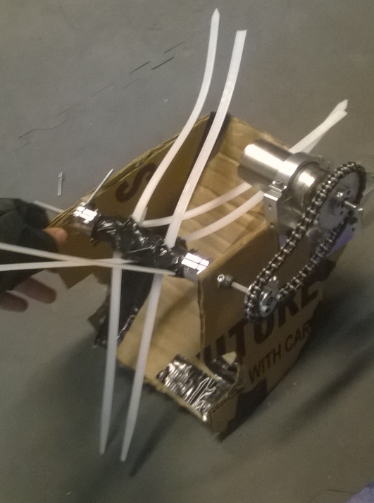

Khan's log
Star date 12/10/14
We have made substantial progress since our last log entry. We stripped the robot down to the KR4 chassis and got rid of all the Da Vinci tube madness and drawer slides. The "shin guards" however have not been effective enough to stop the gear slipping problem so we have decided to switch to chain instead of direct gearing on the drive wheels.
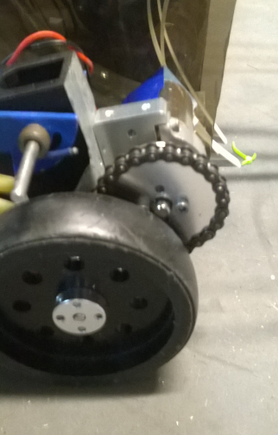
We have also decided to switch our winch over to chain to stop it from slipping as well. Using a dremal we have cut out the pieces for the new intake scoop and the bucket from the CAD model. We sent off dimensions for the sheet metal scoop plate to NASA Armstrong to be metal shopped. However NASA misinterpreted our request and bent the wrong piece of metal. Luckily, we were able to fix the damage and re bend the part on our own. We have opted to use rivets on the new components due to their flush nature.
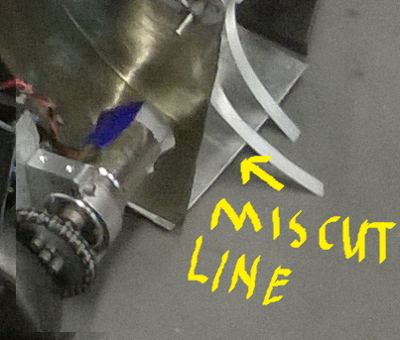

We have encountered some setbacks regarding the type of plastic we are using for the scoop and bucket. The plastic is remarkably brittle and tends to shatter while it is being drilled through or being riveted. This problem has been addressed with a liberal application of duck tape.
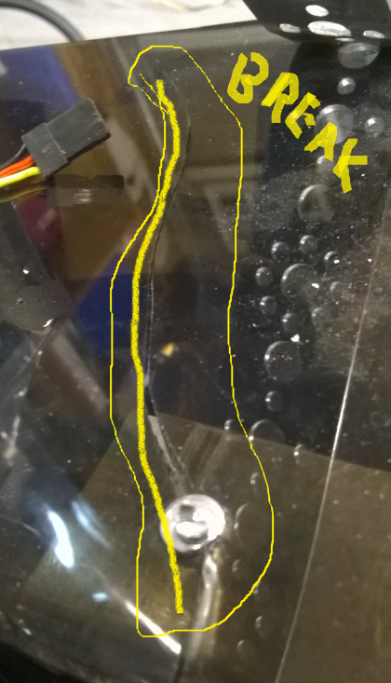
We have also perfected our design of an output funnel that folds flat to act as a door but extends out to make an enclosed tube for the balls travel down.

